Template for Submission of Abstracts to

Cutting Edge 2021

This template must be used for preparing abstracts for submission to Cutting Edge 2021. The template contains much of the formatting information that is used in the Book of Abstracts. The use of the template will save time during the review and production processes and will expedite publication. This template provides authors with the opportunity to gauge the length of their abstracts, eliminating the delay and cost of shortening them to the one-page limit at the galley stage. A general idea of the length will be given by inserting your artwork (displayed equations, figures, schemes, charts, and tables) into the template sized appropriately for final publication. Do NOT modify the template in any way (delete space, modify font size/line height, etc.) to make your abstract fit within the one-page limit.
The abstract length is limited to one (1) page. The abstract must contain the following elements:
- Title (''Heading 1'' style; two line limit)
- List of authors – presenting author must be underlined, corresponding author must be marked with an asterisk (*) (''Normal'' style + Centre alignment)
- Affiliations (''No spacing'' style)
- Abstract text (''Normal'' style)
- Graphic element (color figure/scheme/table) (Caption and table contents in ''Caption'' style)
- References (''No spacing'' style) – Please use ACS style of references, font size 11. Multiple references are allowed. 3-5 references are advised.
- Do not use embedded figures! Save your figures as high resolution .tiff or .jpg files and insert them into the word document.
- Save your document as
''YOURFIRSTNAME_YOURLASTNAME_CE2021_ABS.doc(x)''.
Example: DIMITRI_MENDELEEV_CE2021_ABS.docx

Please delete this page before submission.
Type title here: Abstract to Cutting Edge 2019 (Heading 1 style)
Type author 1 here (full first name + last name),^{1,2} Type author 2 here,³ Underline presenting author,⁴ Mark corresponding author with an asterisk*^{,1,2}
¹ Faculty of Chemistry and Chemical Technology, University of Ljubljana, Večna pot 113, SI-1000 Ljubljana, Slovenia, corresponding.author@email.address
² Type affiliation 2 here
Write abstract text here. Use Times new roman; font 12; justified; line spacing 1,15 (Normal style). Total abstract length is limited to one page. Please delete the instructions page before submission.
"Basic research is performed without thought of practical ends¹. It results in general knowledge and an understanding of nature and its laws (Fig. 1). This general knowledge provides the means of answering a large number of important practical problems, though it may not give a complete specific answer to any one of them- The function of applied research is to provide such complete answers². The scientist doing basic research may not be at all interested in the practical applications of his work, yet the further progress of industrial development would eventually stagnate if basic scientific research were long neglected³."
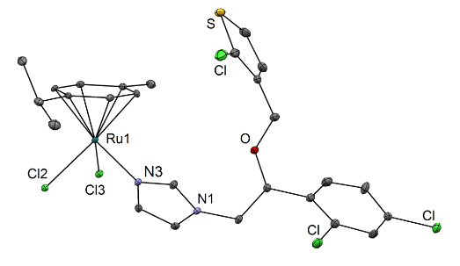
Figure/Scheme 1: Insert figure/scheme and type caption Use Times new roman; font 11; justified; line spacing 1 (Caption style)
Table 1: Insert table and type caption Use Times new roman; font 11; justified; line spacing 1 (Caption style)
 | 1a⁵ | 1b | 2a
Ru-N3 | 2.098(2) | 2.102(4) | 2.107(4) / 2.111(4)
Ru-Cym_{centroid} | 1.664(2) | 1.657(2) | 1.655(2)
1. Kupferschmidt, K., Attack of the clones. Science 2012, 337, 636-638.
2. (a) Alessio, E. (Ed.), Bioinorganic Medicinal Chemistry. Wiley-VCH Verlag & Co. KGaA: Weinheim, Germany, 2011, (b) Lakowicz, J. R., Principles of Fluorescence Spectroscopy. 3rd ed.; Springer: New York, 2006.
3. Wong, E.; Giandomenico, C. M., Current status of platinum-based antitumor drugs. Chem. Rev. 1999, 99, 2451-2466.

